Persistence of Vision Display

Introduce:

Persistence of vision (POV) is a property of the visual system that combines individual visual cues into smooth and seamless images. For this project, our group will develop and implement a POV system powered by a microcontroller that can display words and possibly emoji.

Design graph:

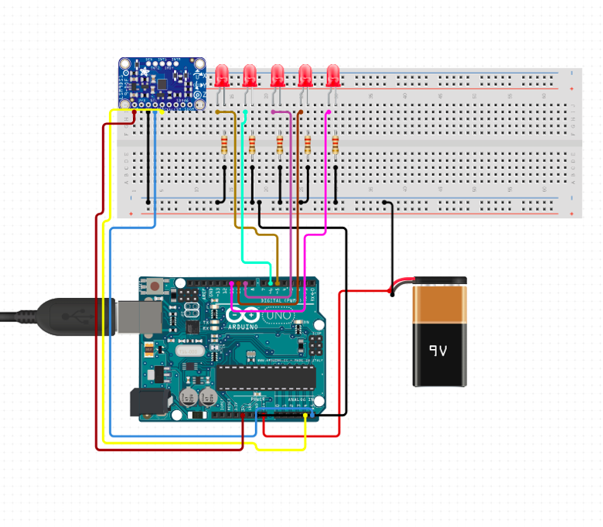

Using 9V DC power as our power supply, and connect to microcontroller Arduino Uno, this microcontroller will provide two output voltages, 3.3V and 5V. In this project, plan use 5V as power supply to 7 LEDs, and each LED connect with 2K ohms resistor. The accelerometer used to determine the direction when swing wand, and control speed.

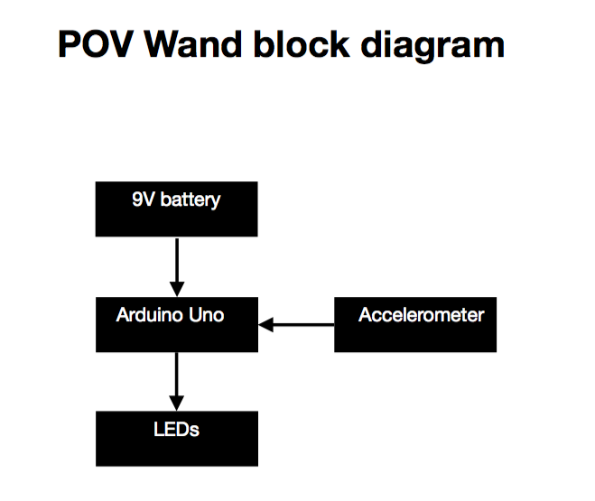

LEDs schematic:

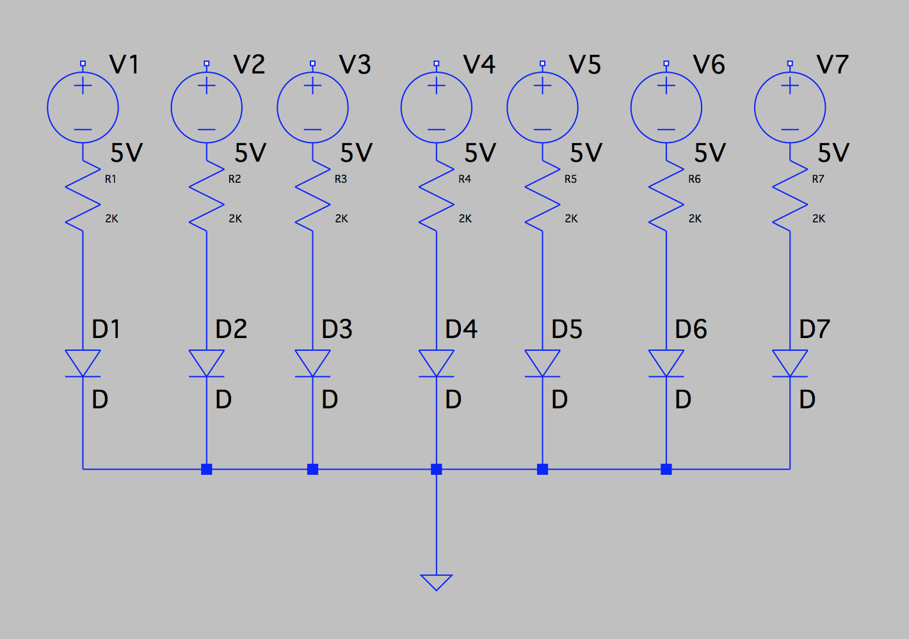

Interface Definition

|  |  |
| --- | --- |
| Name | Properties |
| DC power_to_Microcontroller | Vnominal: 9V  Vo: 5V |
| Microcontroller_to_LEDs | Vnominal: 5V |
| Accelerometer_to_Microcontroller_Comm | Datarate: 9600  Message:acceleration data (m^2)  Protocol: I2C  Vmax: 5V  Vin: 3V  Other: 16 bit data output |
| Outside_envir_to_Accelerometer | Detect acceleration in three axis (X,Y, Z) |
| LEDs_outsider_Usr | Display characters of at least 7X5 pixels |

Code:

Reference:

Accelerometer =>LIS3DH

*UART/Accelerometer connection:

<https://learn.adafruit.com/adafruit-lis3dh-triple-axis-accelerometer-breakout/arduino>

https://www.arduino.cc/en/Tutorial/ADXL3xx

IDEA:

Output from x,y,z. Z gives acceleration and direction. Depending on Z location and speed we can change the rate at which the led will turn on and off.